Full model

*Bảng 1.1. Các thông số kỹ thuật của xe Toyota Vios*

|  |  |  |  |  |
| --- | --- | --- | --- | --- |
| **STT** | **TÊN THÔNG SỐ** | **ĐƠN VỊ** | **GIÁ TRỊ** | **GHI CHÚ** |
|  | | | TOYOTA VIOS 1.5G |  |
| 3 | Kích thước tổng thể (dài x rộng x cao) | mm | 4300 x 1700 x 1460 |  |
| 5 | Chiều dài cơ sở | mm | 2550 |  |
| 6 | Chiều rộng cơ sở (trước/sau) | mm | 1470/1460 |  |
| 8 | Trọng lượng không tải | kg | 1055-1110 |  |
| 9 | Trọng lượng toàn tải | kg | 1520 |  |
| 11 | Vỏ và mâm xe |  | 185/60R15 Mâm đúc |  |

*Bảng 4.1. Góc Camber, caster và góc kingpin*

|  |  |  |  |
| --- | --- | --- | --- |
| Kích Thước Lốp | Camber | Caster | Góc King Pin (Tham khảo) |
| 175/65R14 | -0°08' +/- 0°45' (-0.13° +/- 0.75°) | 4°41' +/- 0°45' (4.68° +/- 0.75°) | 11°14' (11.23°) |
| 185/60R15 | -0°08' +/- 0°45' (-0.13° +/- 0.75°) | 4°41' +/- 0°45' (4.68° +/- 0.75°) | 11°13' (11.21°) |

| **Tire Size** | **Camber** | **Caster** | **King Pin Angle** |
| --- | --- | --- | --- |
| 175/65R14 | -0°08' +/- 0°45' (-0.13° +/- 0.75°) | 4°41' +/- 0°45' (4.68° +/- 0.75°) | 11°14' (11.23°) |
| 185/60R15 | -0°08' +/- 0°45' (-0.13° +/- 0.75°) | 4°41' +/- 0°45' (4.68° +/- 0.75°) | 11°13' (11.21°) |

|  |
| --- |
|  |
| **No.** | **Parameter Name** | **Unit** | **Value** | **Note** |
| 3 | Overall dimensions (length x width x height) | mm | 4300 x 1700 x 1460 |  |
| 5 | Wheelbase | mm | 2550 |  |
| 6 | Track width (front/rear) | mm | 1470/1460 |  |
| 8 | Curb weight | kg | 1055-1110 |  |
| 9 | Gross vehicle weight | kg | 1520 |  |
| 11 | Tires and wheels |  | 185/60R15 Alloy wheels |  |

*Bảng 4.2. Độ chụm tiêu chuẩn*

|  |  |  |
| --- | --- | --- |
| Kích Thước Lốp | A+B (Tham khảo) | C-D |
| 175/65R14 | 0°10' (0.17°) | 1.5 +/- 2.0 mm (0.05 +/- 0.08 in.) |
| 185/60R15 | 0°4' (0.07°) | 1.6 +/- 2.0 mm (0.06 +/- 0.08 in.) |

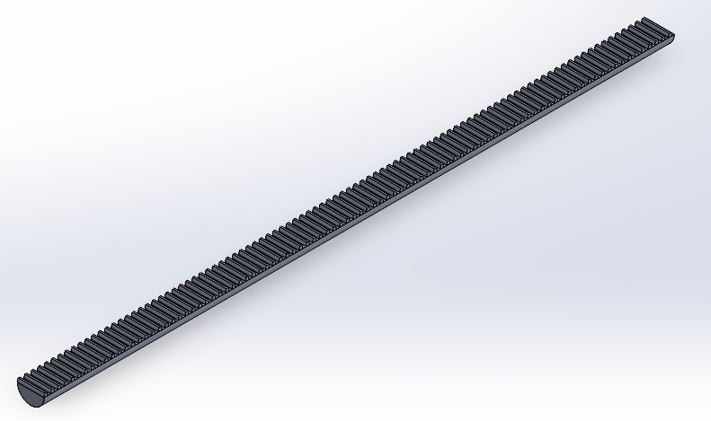Working rack length : 0.37m

Track width : 1.4m

Pinion : rack ratio : 1:3

Tie rod length : 0.265m

Steering linkage / steering arm length : 0.1m

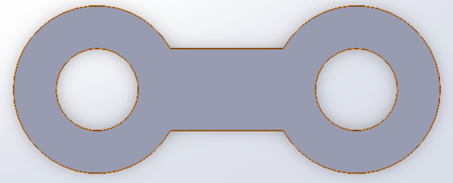

| **Parameter** | **Unit** | **Value** |
| --- | --- | --- |
| Wheelbase | mm | 2550 |
| Distance between two vertical pillars | mm | 1470 |
| Radius of steering wheel | mm | 180 |
| Steering gear ratio |  | 19.5 |
| Wheel radius | mm | 354 |
| Number of teeth on the pinion |  | 9 |
| Number of teeth on the rack |  | 27 |

Chapter : How to export from Solidworks to Simulink on MATLAB

**Step 1:** Enable Simscape Multibody Link Plugin in SolidWorks

The Simscape™ Multibody™ Link plugin allows SolidWorks® CAD assembly models can be exported to Simscape Multibody. To download and install the plugin, watch on:  [Install the Simscape Multibody Link Plugin](https://www.mathworks.com/help/smlink/ug/installing-and-linking-simmechanics-link-software.html).

**Enable the Plugin**

To enable the plugin:

1. At the MATLAB® command prompt, enter [smlink_linksw](https://www.mathworks.com/help/smlink/ref/smlink_linksw.html).
2. Start SolidWorks.
3. On the SolidWorks menu bar, click **Tools** > **Add-Ins**.

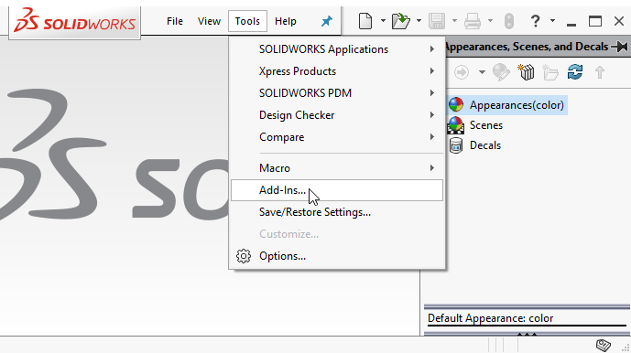

1. In the Add-Ins dialog box, select the **Simscape Multibody Link** check box.

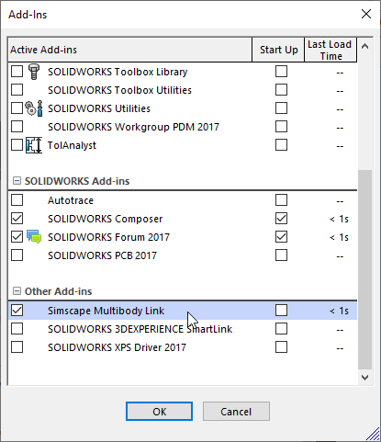

After enabling the plugin, **Simscape Multibody Link** option is available when SolidWorks assembly is opened. To export an assembly model, on the menu bar, click **Tools** > **Simscape Multibody Link** > **Export** > **Simscape Multibody**.

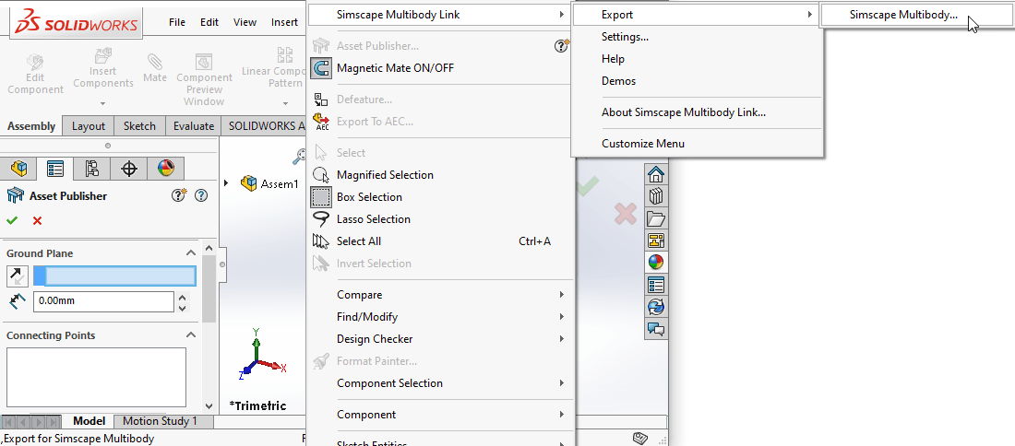

Step 2: Use smimport to get .xml file that exported from Solidworks to Simulink

1. To export an assembly drawing to Matlab Simulink, we need to open the drawing file type Assembly go to Add-Ins and click Export Simscape Multibody, choose where to save the file and file name (usually the file name is recommended by name drawing Assembly), the file will be created in the .xml which is format of Simscape Multibody Link.

2. To open the file, first after starting Matlab need to select the folder containing file: click Browse for folder and select the folder containing the file, then click Select Folder

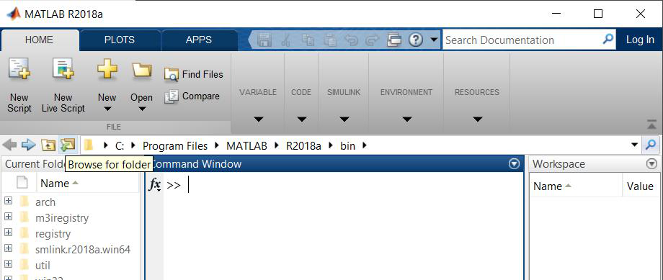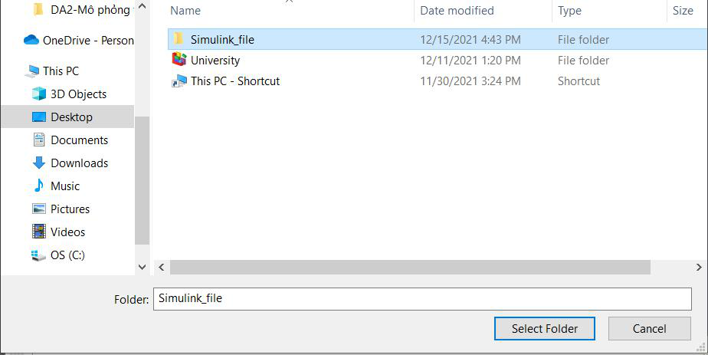

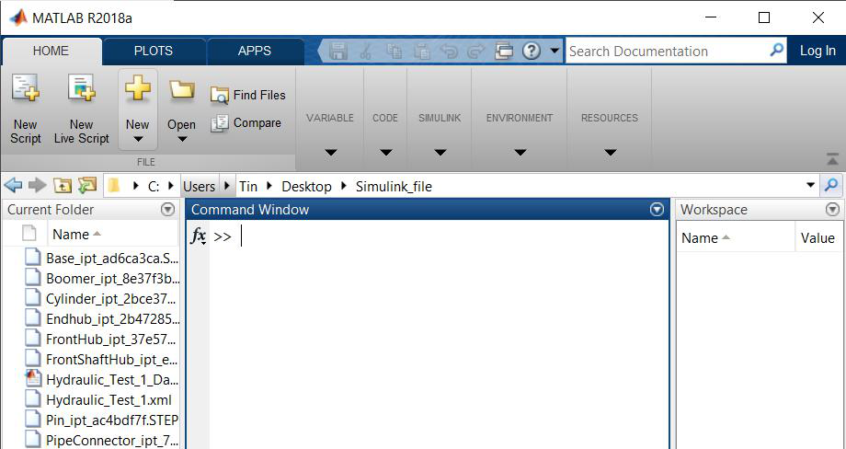 *Mở thư mục lưu file .xml*

3. In the Command Window in Matlab, enter the command smimport(‘filename.xml') and wait for the importing model to finish running

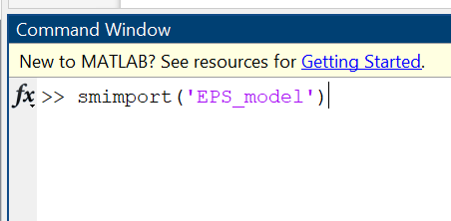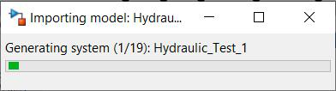

4. Then we get the Simulink window with the 3D drawing in the Inventor converted to Matlab Simulink as functional blocks

1. A computer screen shot of a wheel

   Description automatically generated with medium confidenceIn the Simulink window, you can select Run and check if the mechanism runs as designed in the Mechanics Explorers dialog box

| **Name and Symbol** | **Function and Configuration** |
| --- | --- |
| Subsystem | Contains a set of blocks within a model or system. A Subsystem block may represent a virtual subsystem or a nonvirtual subsystem. For example, in Figure 5.1, there are Subsystem blocks for Fluids, Simulink, Multibody, etc. |
| Inport | Brings a signal from outside a system into the system. The port number of an Inport block is assigned as follows: it is automatically numbered sequentially in the highest-level system or subsystem. If a new Inport block is added, its label is the next available number. If an Inport block is deleted, the port numbers of other blocks are automatically reassigned to ensure that the Inport blocks are numbered sequentially and that no numbers are skipped. If an Inport block is copied into a system, its port number is not reassigned unless its current number conflicts with an existing input port in the system. If the Inport block's port number is not sequential, renumber the block. Otherwise, an error message will be received when simulating or updating the block diagram. |
| Outport | Sends a signal from a system to an external destination. They can connect signals transmitted from a subsystem to other parts of the model. They can also provide the top-level outputs of a hierarchical model. The port number of an Outport block is assigned as follows: Outport blocks in the base-level system or subsystem are numbered sequentially, starting with 1. If a new Outport block is added, it is assigned the next available number. If an Outport block is deleted, the port numbers of other blocks are automatically reassigned to ensure that the Outport blocks are numbered sequentially and that no numbers are skipped. |
| Connection Port | This block is used in a subsystem when physical ports need to be connected. |
| Mechanism Configuration | Sets mechanical parameters and applies simulation for the entire machine, target machine that the block is connected to. In the Properties section below, we can specify a uniform gravity force for the entire mechanism and set linear delta t. Port C is the frame node that we connect to the target machine with a connection path at any frame node of the machine. |
| World Frame | Provides a space with a stationary, orthogonal coordinate frame, defined by the right-hand rule, in any mechanical model. The World Frame is the basis of all frame networks in a mechanical model. A model can have multiple World Frame blocks, but they all represent the same frame. Port W is a frame port defined with the World Frame. Any frame port directly connected to W is also defined with the World Frame. |
| Rigid Transform | Determines a fixed 3D rigid transformation between two frames. The two components independently specify the translational and rotational parts of the transformation. Translation and rotation motions can be combined freely. Ports B and F correspond to the Base and Following Frames, respectively. |
| Revolute Joint | Connects two frames with a hinge joint that has only one degree of freedom. Port B corresponds to the Base and F corresponds to the Following Frames. In the expandable nodes under Properties, we can specify state targets, actuation methods, sensing, and internal mechanics. |
| Reference Frame | Defines a frame to which other frames in the network can be referenced or blocks can be attached. (Optional) Port R is a frame port defined with the reference frame. Any frame port directly connected to R is also defined with the reference frame. |
| Cylindrical Joint | Connects two frames with a cylindrical joint that has one translational and one rotational degree of freedom. Port B corresponds to the Base and F corresponds to the Following Frames. In the expandable nodes under Properties, we can specify state targets, actuation methods, sensing, and internal mechanics (equilibrium position, spring stiffness, damping coefficient) of these joints (one translation along Z and one rotation around Z). After applying these settings, the block will display corresponding physical signal ports. |
| Planar Joint | Represents a planar joint between two frames. This joint has two translational and one rotational degree of freedom. Port B corresponds to the Base and F corresponds to the Following Frames. In the expandable nodes under Properties, we can specify state targets, actuation methods, sensing, and internal mechanics (equilibrium position, spring stiffness, damping coefficient) of these joints (two translations along X and Y and one rotation around Z). After applying these settings, the block will display corresponding physical signal ports. |
| Prismatic Joint | Connects two frames with a prismatic joint that has only one translational degree of freedom. Port B corresponds to the Base and F corresponds to the Following Frames. In the expandable nodes under Properties, we can specify state targets, actuation methods, sensing, and internal mechanics (equilibrium position, spring stiffness, damping coefficient) of this joint (one translation along Z). After applying these settings, the block will display corresponding physical signal ports. |
| Gain | The Gain block multiplies the input signal by a constant value (gain). The input can be a scalar, vector, or matrix signal. The value of the Gain can be specified in the Gain parameter. The Multiplication parameter allows us to specify element-wise or matrix multiplication. For matrix multiplication, this parameter also allows us to specify the order of the multiplication. |
| Signal Editor | The Signal Editor block displays, creates, and edits signal parameters that can be exchanged between blocks. This block can be used to convert signal parameters inside and outside the model. |
| Converter | The Converter block converts Simulink signals to physical signals. |
| PS Constant | The PS Constant block generates a physical signal with a constant value. The value and unit of the signal can be specified as a constant. |
| Solver Configuration | The Solver Configuration block specifies the solver parameters required for a Simscape block diagram to start simulation. Each Simscape block diagram has a unique structure and connectivity that requires an accurate Solver Configuration block to be connected to it. The solver configuration parameters include the type of solver to be used, the maximum step size, the relative and absolute tolerances, the maximum number of iterations, and other solver-specific options. The Solver Configuration block allows the user to specify these parameters and configure the solver accordingly. Choosing the appropriate solver configuration is important for obtaining accurate and efficient simulation results. The default solver configuration in Simscape is suitable for most models, but for complex models or those with stiff differential equations, a different solver configuration may be necessary for accurate and efficient simulation. |
| PS-Simulink Converter | The PS-Simulink Converter block converts physical signals to Simulink signals. |
| Scope | The Scope block displays the signals generated during simulation. It can be used to visualize the behavior of different signals and debug the model. |
| Mux | The Mux block combines separate signals into a single vector signal. This block can be used to combine multiple signals into a single signal for further processing or analysis. |